Containerising an App

1. How to write a Docker file

Example: -

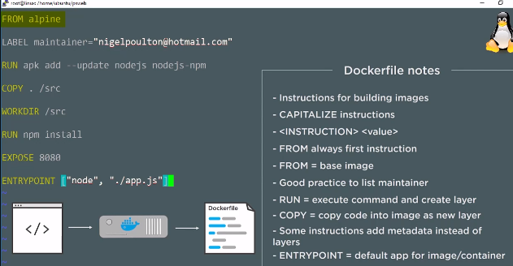

1. Building:

docker image build –t [image name] . (. Means to use files in current directory)

1. Container

docker container run –d -- [name] -p 8080:8080 [image name] (-d means detached, doesn’t use the terminal)

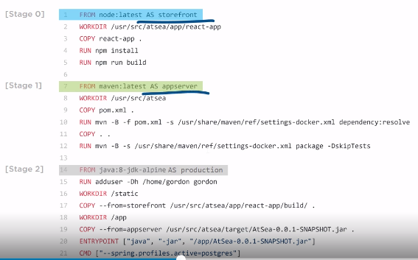

Working with Containers

docker container run –it alpine sh (Allows to remote into the container with a shell on start-up)

docker container exec –it [part of unique identifier] sh (remote into a running container)

Ctrl + p + q (used to exit remote terminal)

Networking

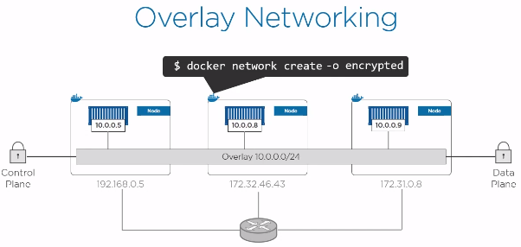

Services and Stacks

Stacks are microservice apps that are containerised and grouped into services.

Stacks are defined in a Yamal file.

